**DBMS Lab Assignment 4**

**Neeti Kurulkar**

**Library Management System**

**Queries:**

1. **Create Tables**

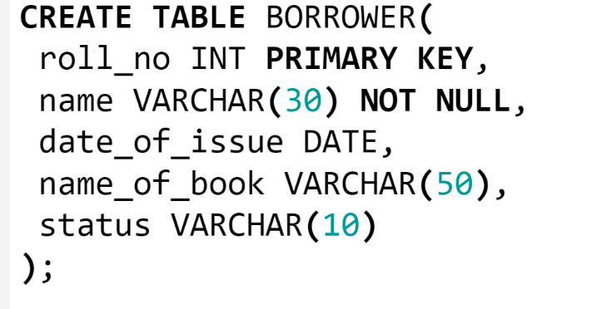

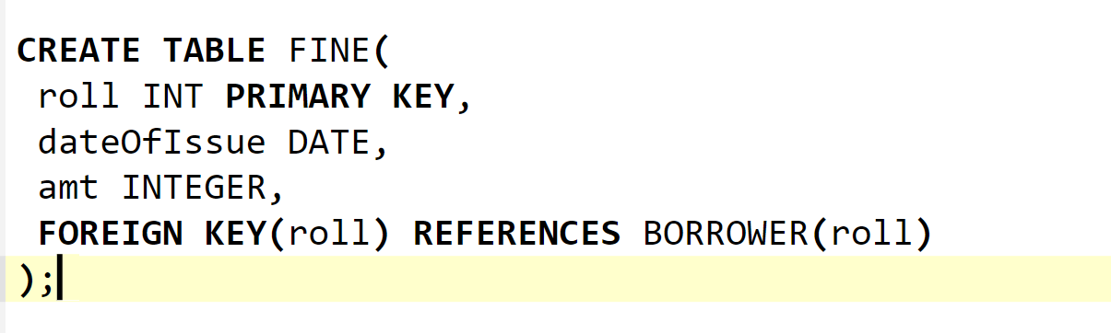

1. **Enter values**

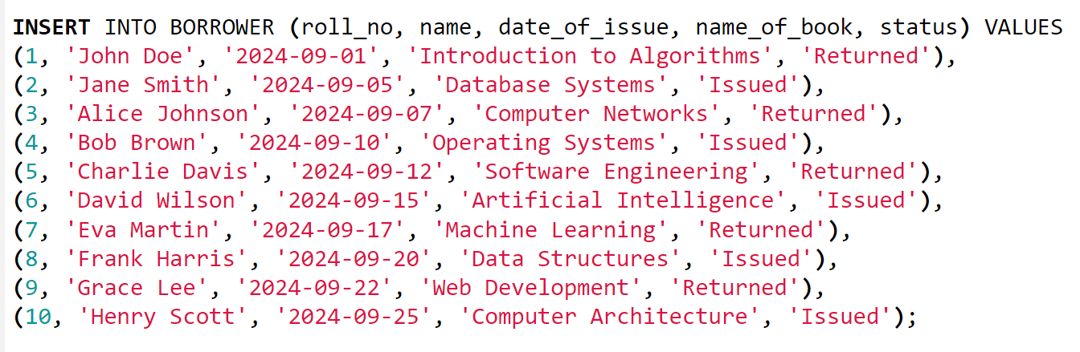

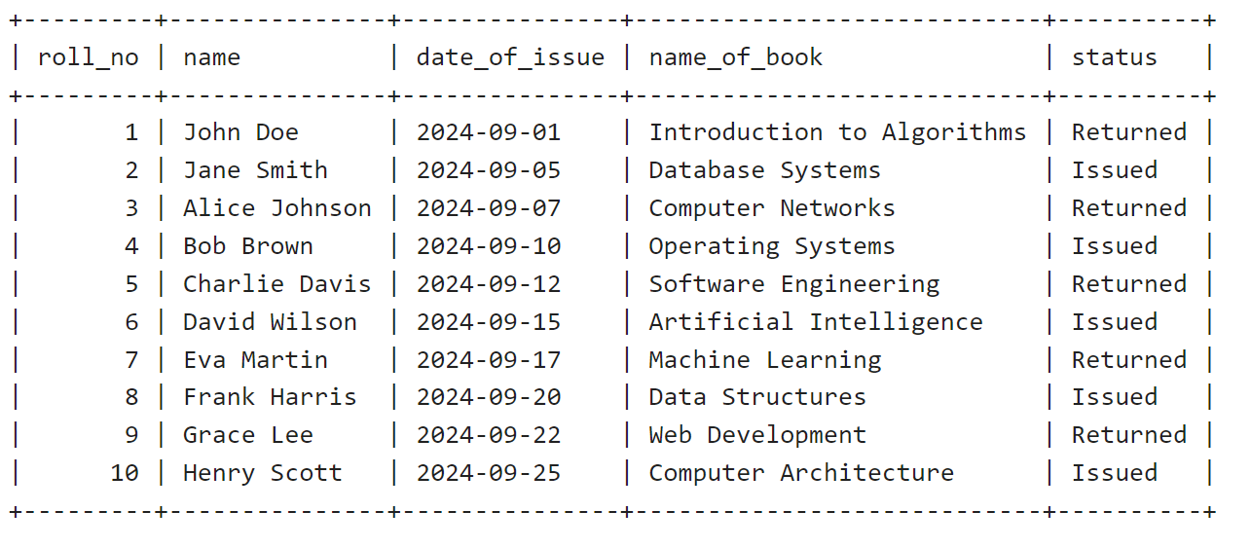

1. **Create Procedure**

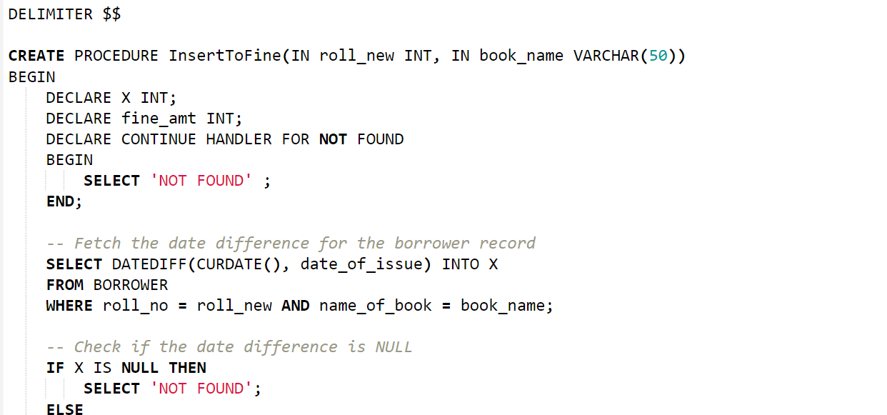

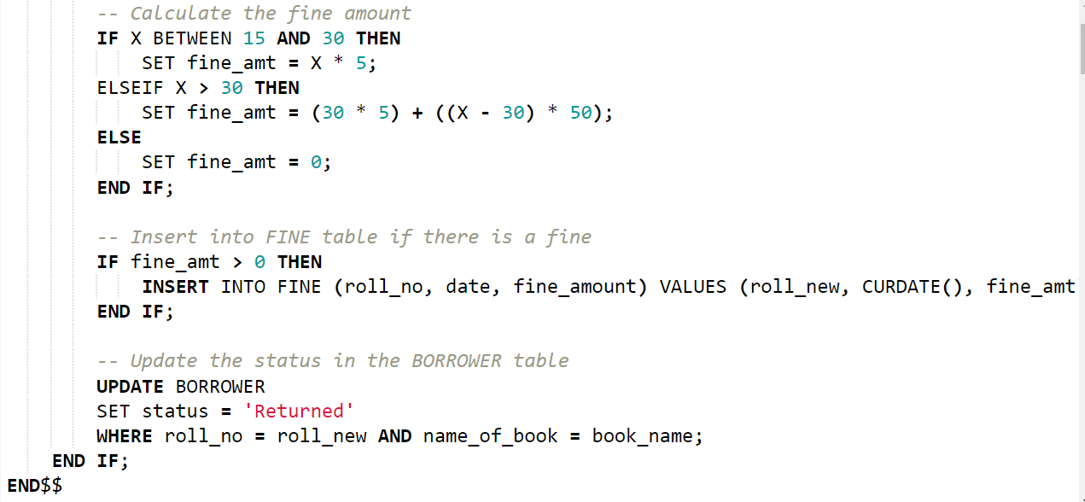

1. **Call Procedure**

